
School: ............................................................................................................. Campus: ....................................................... Academic Year: ...................... Subject Name: ........................................................... Subject Code: ..........................
Semester: ............... Program: ........................................ Branch: ......................... Specialization: .......................... Date: .....................................
(Learning by Doing and Discovery)
* Coding Phase: Pseudo Code / Flow Chart / Algorithm
- ETH → DAI Swap on Aave (on Testnet Network)
Prerequisites:
- Ethereum wallet (e.g., MetaMask) connected to Aave.
- ETH in your wallet (on Ethereum testnet example Ethereum sepolia).
- Some ETH for gas fees.
- Swap Procedure on app.aave.com:
- Go to: https://app.aave.com
- Connect your wallet
  - Top-right : Click Connect Wallet
  - Choose MetaMask .
  - Approve connection.
- Select the Network (Ethereum)
  - Make sure it is Sepolia.
  - Switch to Ethereum testnet if necessary in MetaMask.
- Go to "Swap"
  - Left menu : Click Swap (under “More” or directly visible).
  - This uses ParaSwap under the hood.
- Choose the tokens
  - From: ETH
  - To: DAI
- Enter the amount
  - Enter how much ETH you want to swap.
- Review Rates
  - Aave fetches best routes from decentralized exchanges via ParaSwap.
  - You’ll see slippage, minimum received, and fees.
- Approve ETH (if required)
  - The first time, you’ll need to approve using ETH in swap.
- Click "Swap"
  - Confirm in MetaMask (watch for gas fees).
  - Wait for the transaction to be confirmed.
- Done
- After confirmation, DAI will show in your wallet and Aave dashboard.

Coding Phase: Pseudo Code / Flow Chart / Algorithm

* Softwares used
To swap ETH to DAI on app.aave.com (on Ethereum Mainnet), the entire process involves multiple blockchain protocols and software components working together.
  - Frontend end : React.js, Web3.js/Ether.js, wallet integration
  - Backend Services: Aave Protocols V3, ParaSwap API, The Graph
  - Smart Contracts (On-chain): Aave Pool & Lending Contracts,DAI Token Contract,ParaSwap Smart Contracts.
  - Browser Extensions & Wallets: MetaMask (browser extension),WalletConnect

- Testing Phase: Compilation of Code (error detection)

- Implementation Phase: Final Output (no error)
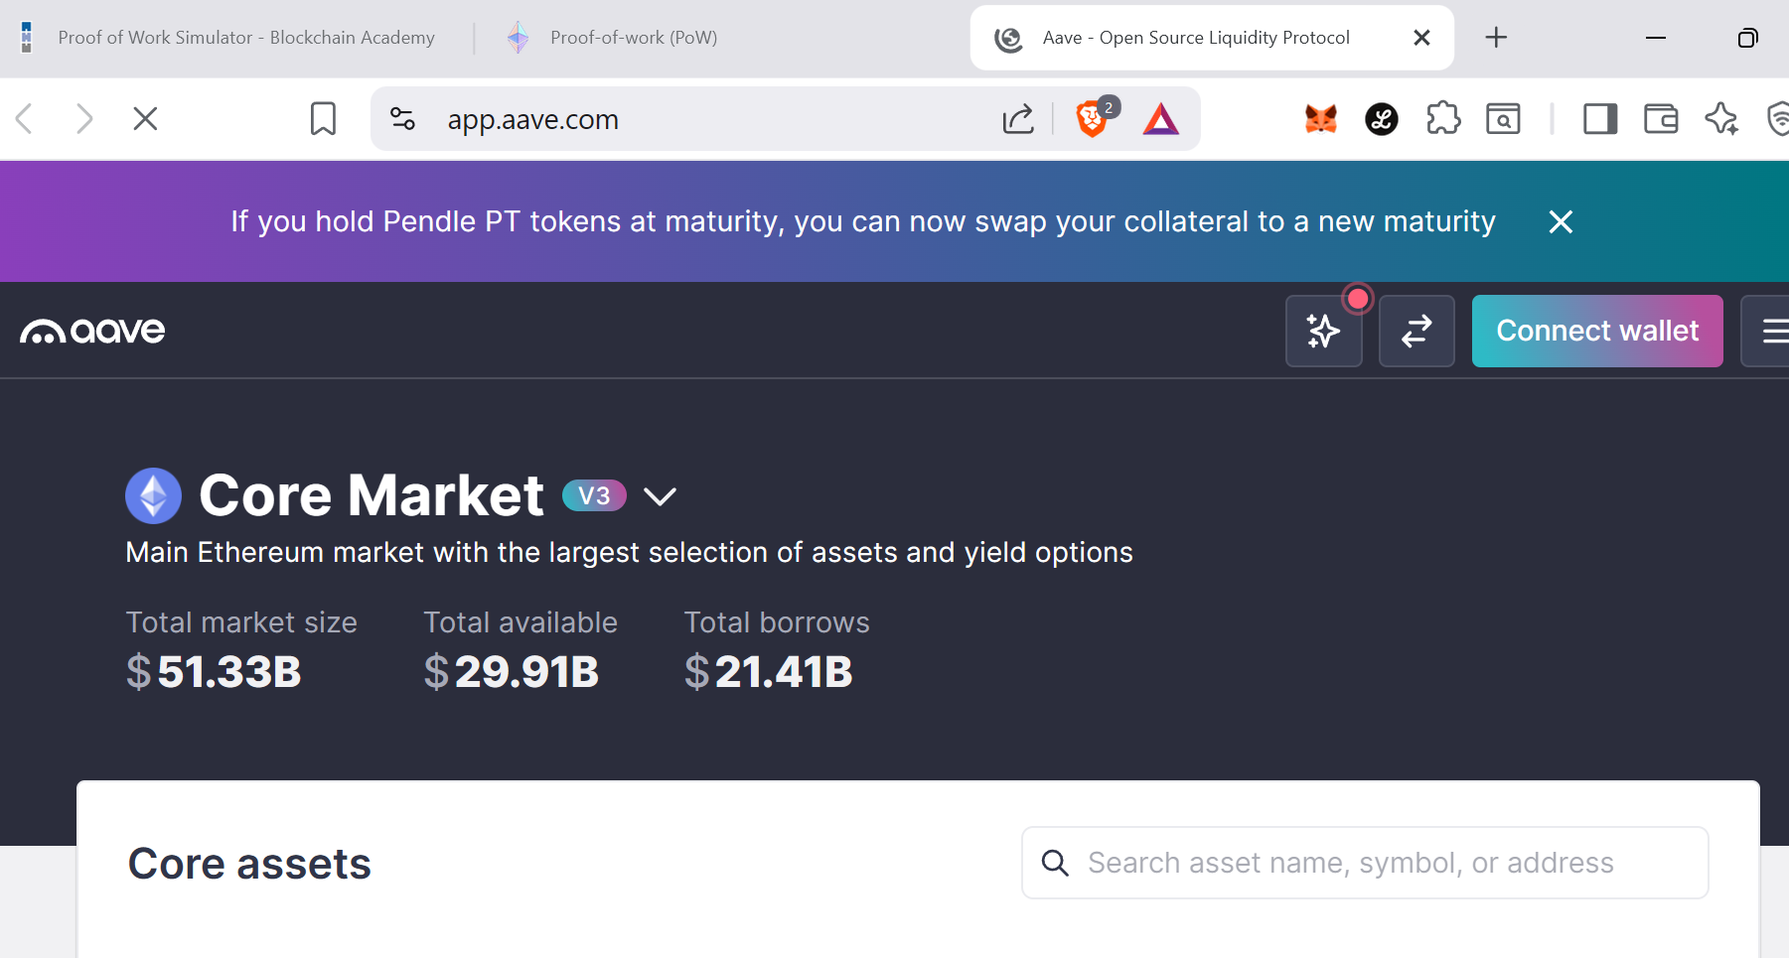

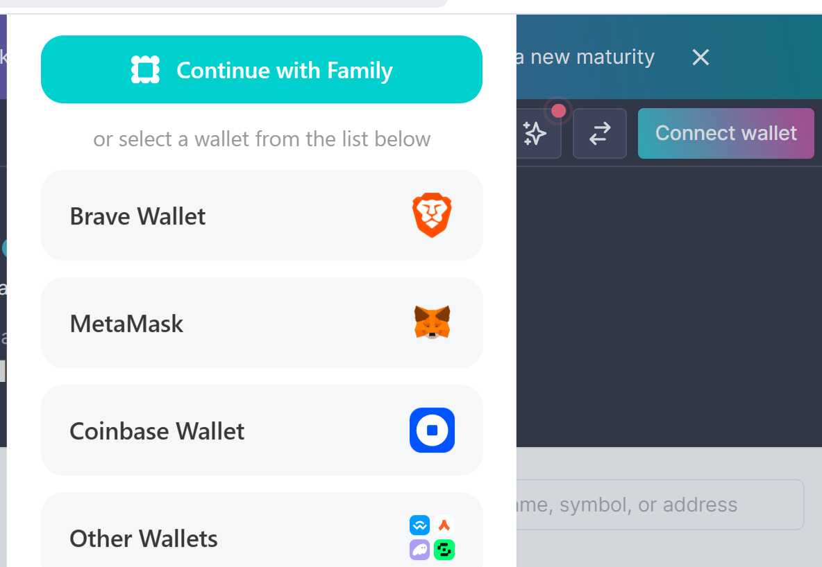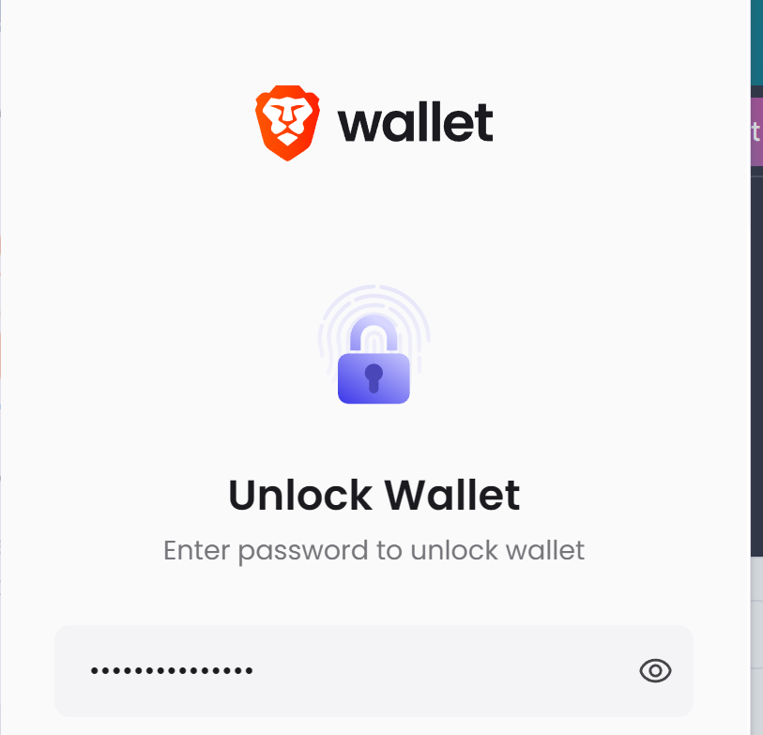

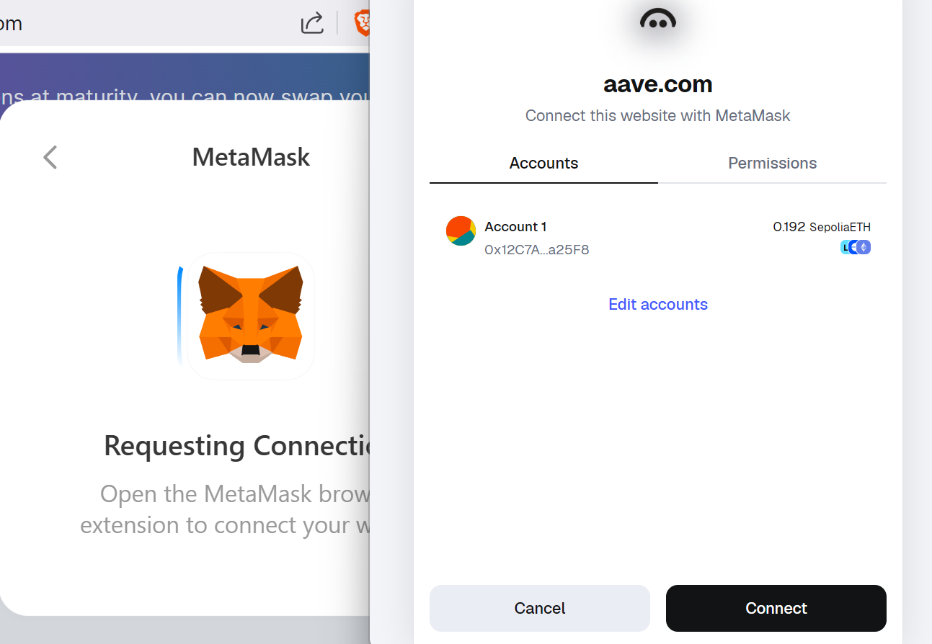

Implementation Phase: Final Output (no error)
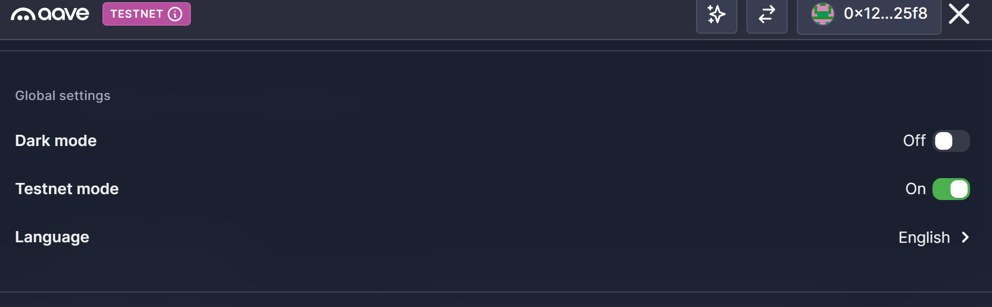

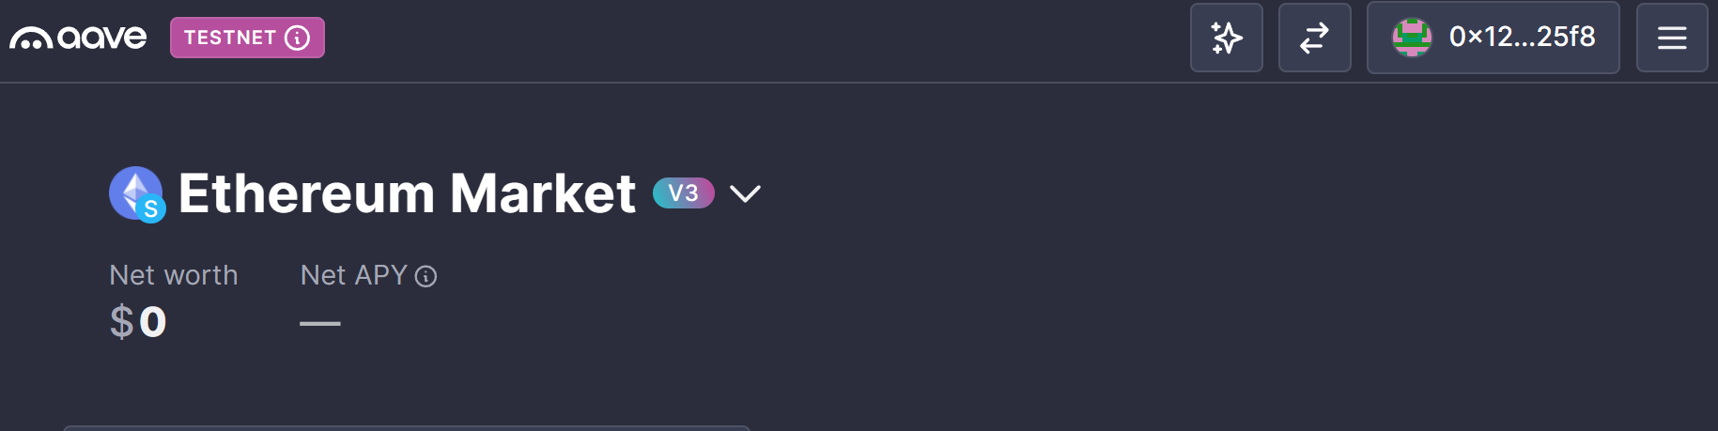

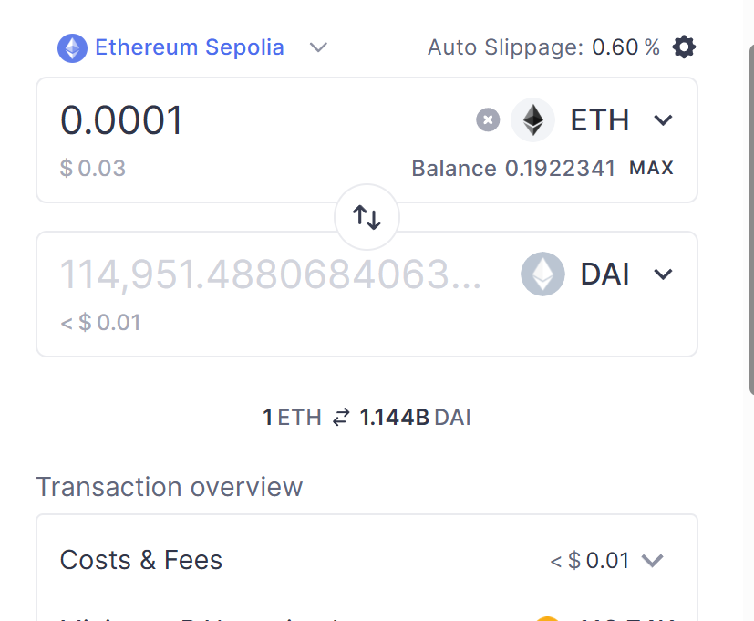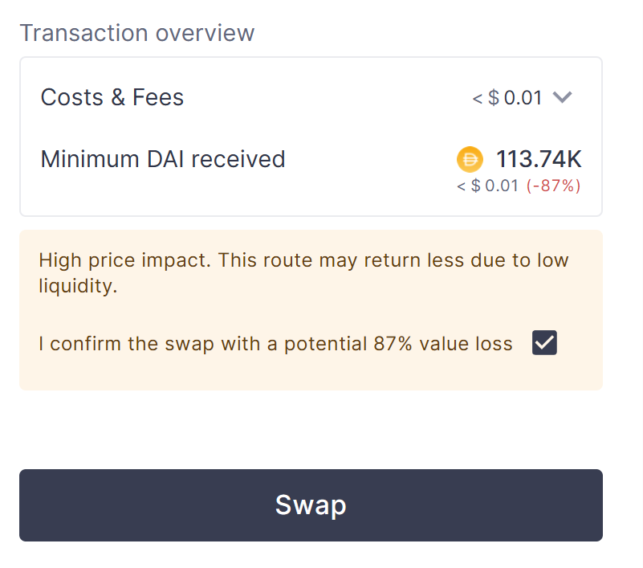

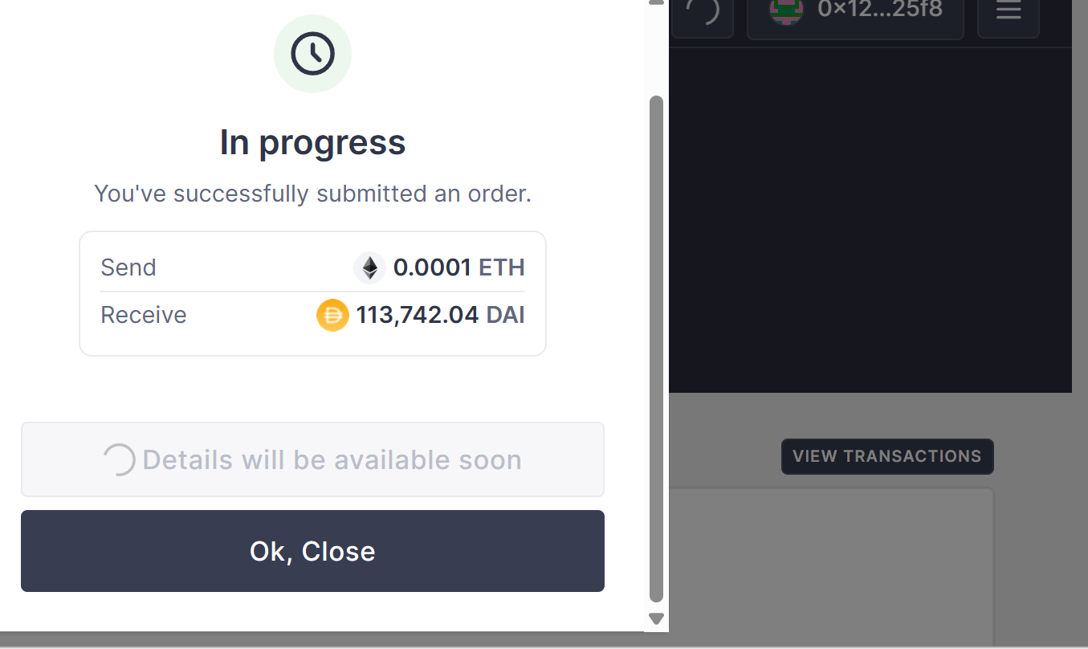

Implementation Phase: Final Output (no error)

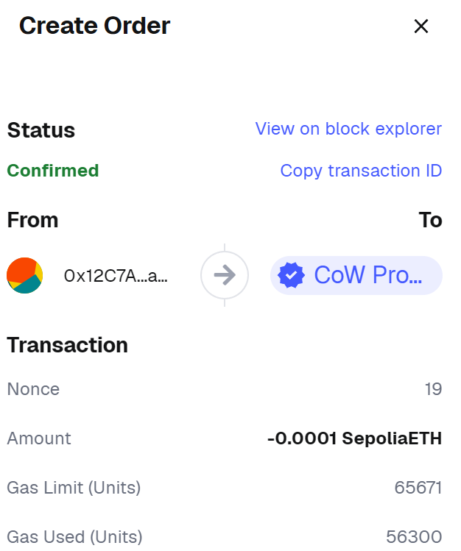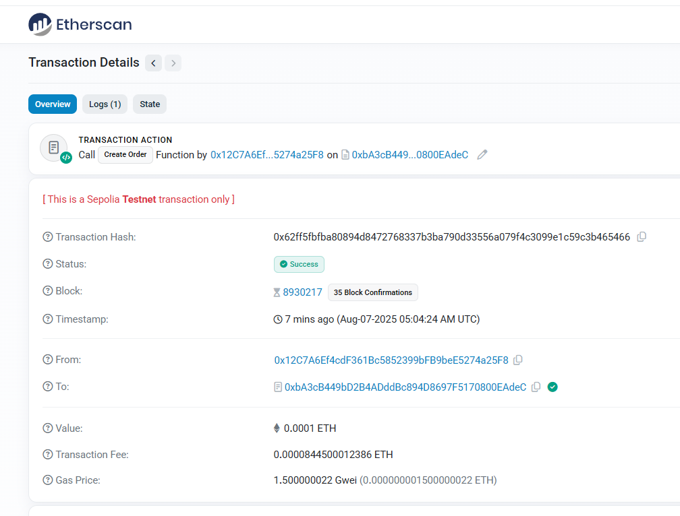

Transaction ID - 0x62ff5fbfba80894d8472768337b3ba790d33556a079f4c3099e1c59c3b465466

* Observations
Observation Post Swap (Results)
What Happens | Observation
- DAI Balance | Increases in your wallet or Aave dashboard.
- ETH Balance | Decreases due to the swap + gas fee.
- Transaction Hash | Viewable on Etherscan with full detail of how ETH was routed and DAI was received.
- Gas Usage | Typical gas usage is 150k–300k depending on complexity of the swap path.

ASSESMENT

Rubrics
Concept | 10
Planning and Execution/  Practical Simulation/ Programming | 10
Result and Interpretation | 10
Record of Applied and Action Learning | 10
Viva | 10
Total | 50


Signature of the Student: PN Archana
Signature of the Faculty:

